PENETRATION TESTING REPORT - DAY 11
Vulnerability Validation - Metasploitable 2
Student Name: Urooj
Target IP: 192.168.56.102
Date: 25 Sep 2026

1. EXECUTIVE SUMMARY
On Day 10, automated scanning (Nmap) identified multiple potential vulnerabilities. On Day 11, manual validation was performed to confirm these findings. All 4 tested vulnerabilities were confirmed as True Positives with concrete proof-of-concept evidence.

2. VALIDATION DETAILS

[VULN-01] FTP Anonymous Login - CRITICAL - CONFIRMED

Description: FTP service allows anonymous login, allowing any user to access files without authentication.

Validation Command:
ftp 192.168.56.102
Name: anonymous
Password: (blank)

Result: Login successful with message "230 Login successful."

Proof] 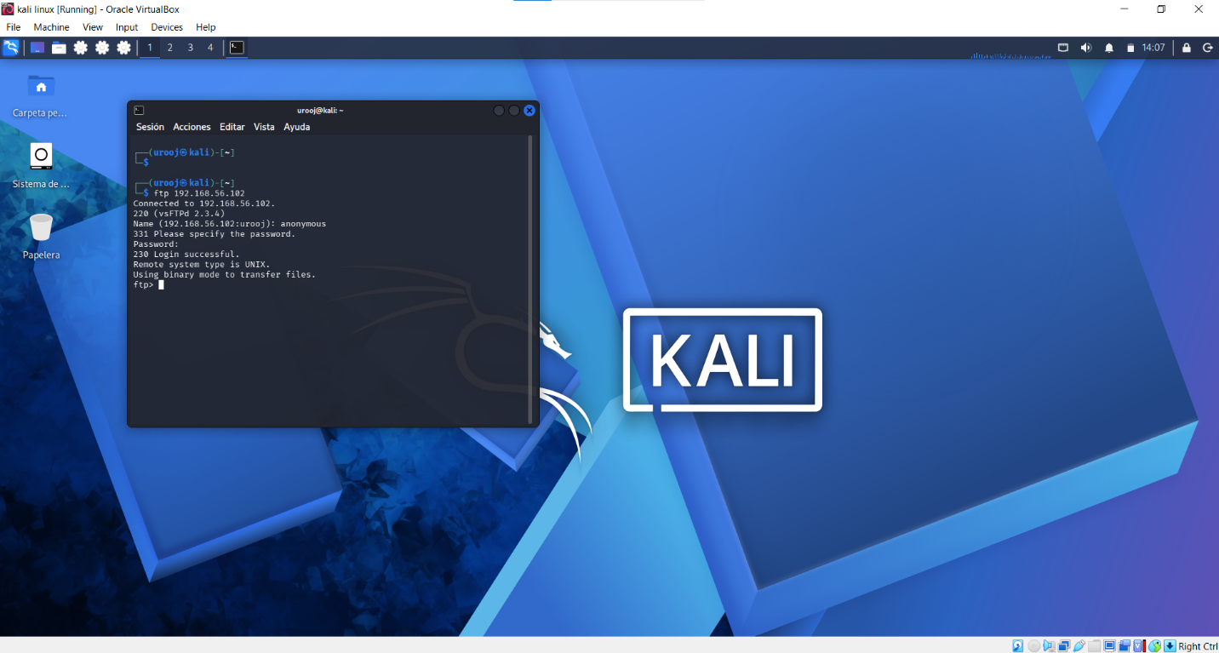

Impact: An attacker can read, download, and potentially upload malicious files to the FTP server.

Remediation: Disable anonymous FTP login in vsftpd.conf -> anonymous_enable=NO

[VULN-04] SMB Anonymous Access and Writable Share - CRITICAL - CONFIRMED

Description: SMB service allows anonymous access and exposes a writable share /tmp.

Validation Command 1 (Share Enumeration):
smbclient -L //192.168.56.102 -N

Result: Anonymous login successful. Shares listed: print$, tmp, opt, IPC$, ADMIN$. Target is METASPLOITABLE.

Proof:
[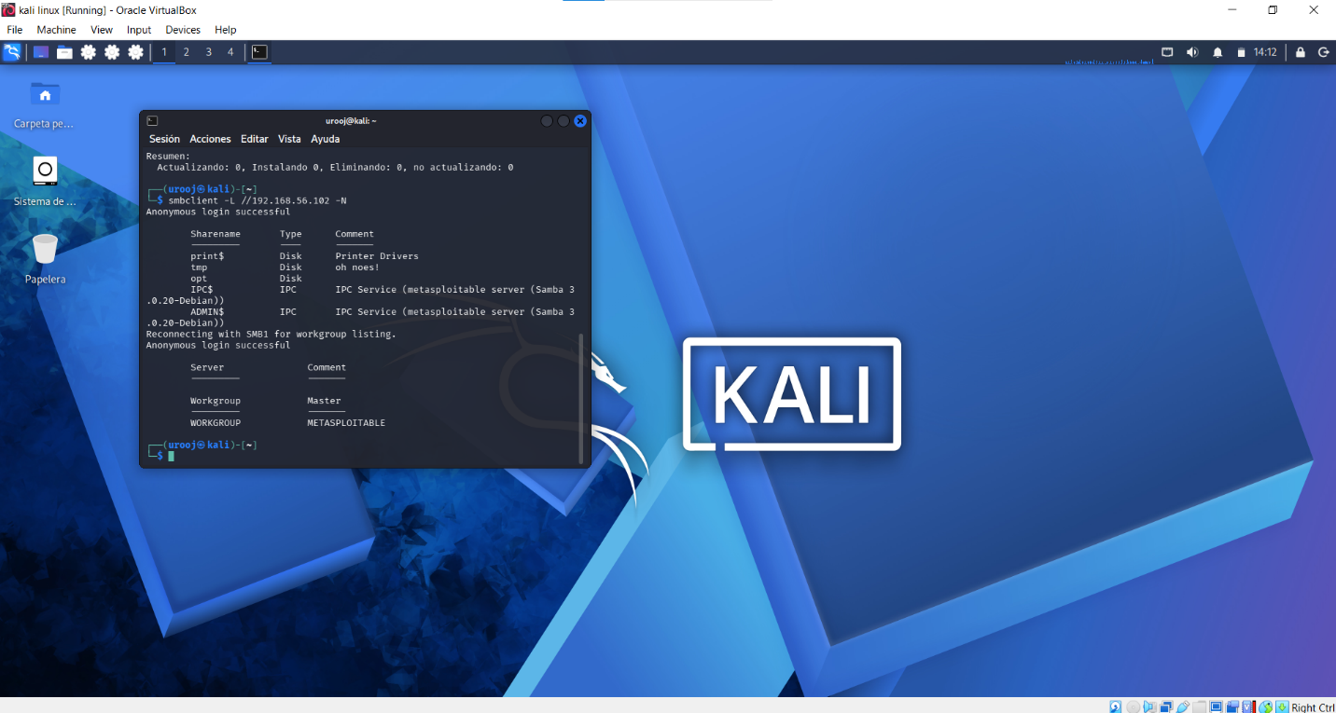: smbclient -L Anonymous login successful]

Validation Command 2 (Accessing Writable Share):
smbclient //192.168.56.102/tmp -N
smb: \> ls

Result: Successfully listed files inside tmp share: .ICE-unix, 4601.jsvc_up, .X11-unix, .X0-lock etc. with 7282168 blocks.

Proof:
[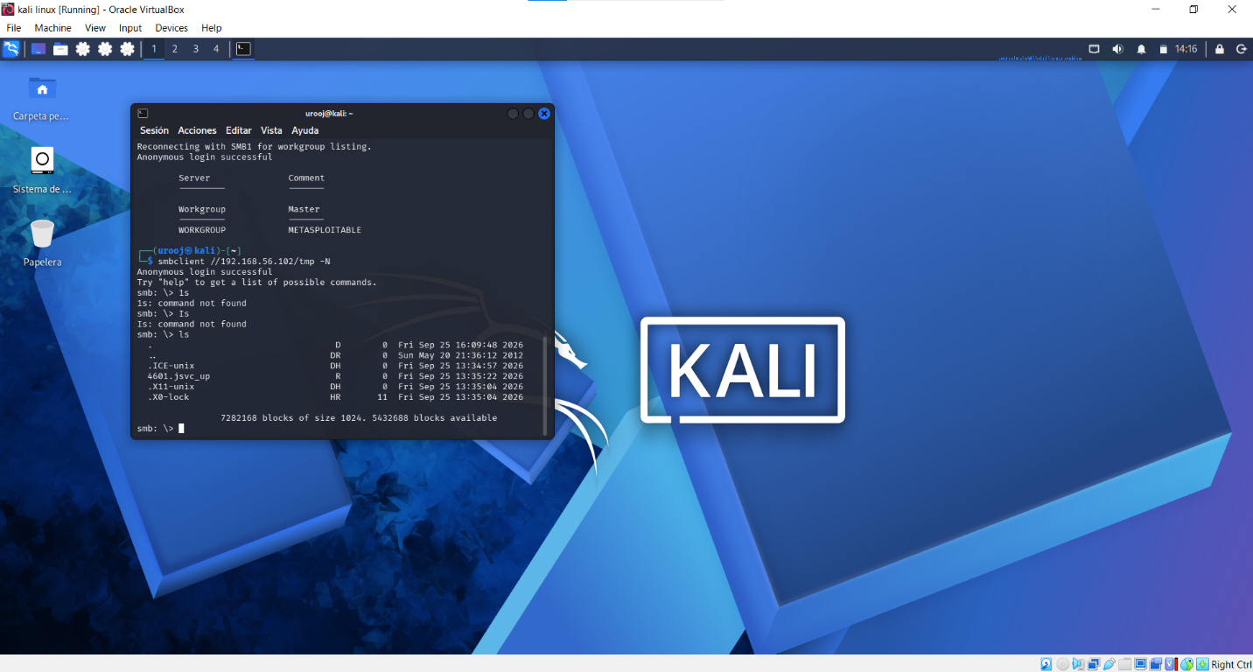: smbclient //tmp ls command]

Impact: Attacker can read/write/execute files via SMB. This can lead to remote code execution.

Remediation: Disable anonymous SMB access, set guest ok = no, and restrict permissions on tmp share.

[VULN-03] Outdated Web Server - MEDIUM - CONFIRMED

Description: Web server is running an outdated and vulnerable version.

Validation Command:
curl -I http://192.168.56.102

Result:
HTTP/1.1 200 OK
Server: Apache/2.2.8 (Ubuntu) DAV/2
X-Powered-By: PHP/5.2.4-2ubuntu5.10

Proof:
[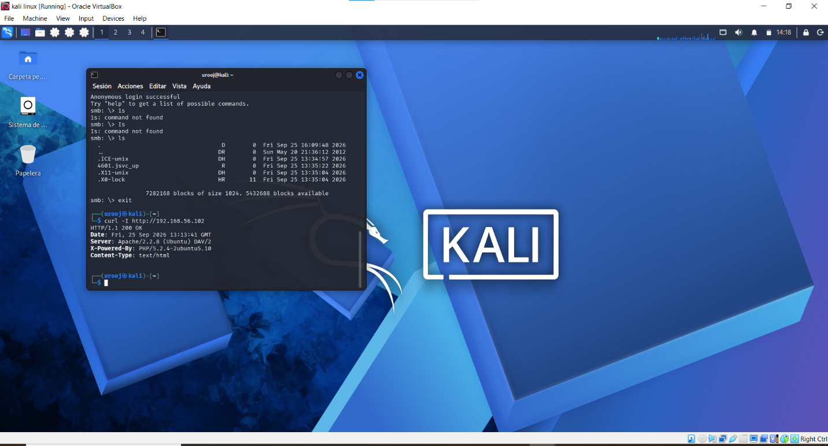: curl -I Apache/2.2.8]

Impact: Apache 2.2.8 (2008) and PHP 5.2.4 have known critical vulnerabilities (CVE-2009- etc.) that allow information disclosure and remote code execution.

Remediation: Upgrade Apache to latest 2.4.x version and PHP to 8.x version.

[VULN-05] Telnet Service Enabled (Cleartext Protocol) - HIGH - CONFIRMED

Description: Telnet service is running on port 23. It transmits data including passwords in cleartext.

Validation Command:
nc 192.168.56.102 23

Result: Port is open and returns Telnet banner/garbled characters (IAC negotiation), confirming service is active.

Proof:
[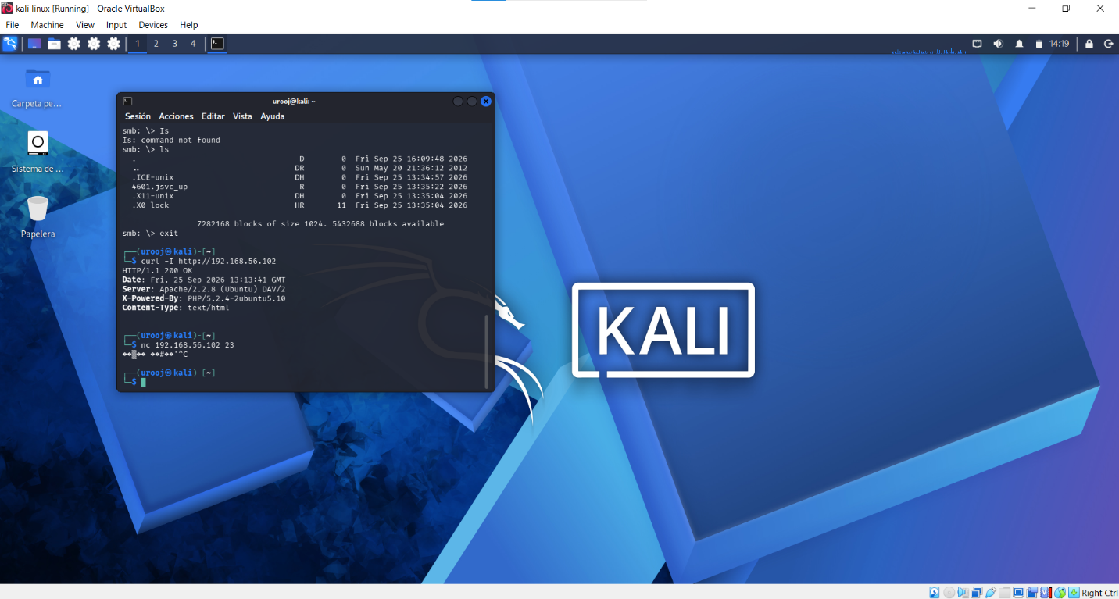: nc 192.168.56.102 23]

Impact: Attacker can sniff credentials and gain unauthorized access.

Remediation: Disable Telnet service and use SSH (port 22) with strong encryption.

3. CONCLUSION
All 4 vulnerabilities from Day 10 were successfully validated on Day 11. The target Metasploitable 2 machine is highly vulnerable and requires immediate hardening.

Total Validated: 4/4 - 100% True Positive Rate

